A young girl with Williams Syndrome – a genetic irregularity that is often associated with learning disabilities
Disabled? How far have people with learning disabilities been included in the societies they lived in?
“If you are reading and teaching the history of learning disability, then you are engaging with a fascinating history of a group of interesting people who have always had a struggle to be included in society.”
Simon Jarrett
Author Those they called idiots: the idea of the disabled mind 1700 to the present day

Why learn about this?
As long as there have been people in the world there have been people who have not been able to learn as quickly as others. Today these people are often described as having learning disabilities.
Sometimes we know the reason for this and sometimes we do not.
Perhaps you feel you have learning disabilities or have friends or members of your family who do.
Tasks may take people with learning disabilities longer, and they may need help to do some things others can do on their own. They may also need help to stay safe, to make and keep friends, to care for themselves and to stay healthy.
How people have defined learning disability has changed over time.
People who are regarded as having learning disabilities today may not have been regarded as having any disability at all in some past societies.
Just as people without learning disabilities are different so people with learning disabilities are different to each other too. Disabilities range from very mild to severe. Like all people, those with learning disabilities have likes and dislikes, ideas, dreams, hopes and fears.
Like everyone they find some things funny and other things sad.
In this enquiry you will learn about how different societies at different times and in different places have both included and excluded people with learning disabilities and reasons for this. There are upsetting examples of cruelty but also love and humour too.
This booklet is about people with learning disabilities, but it is not just a history of people with learning disabilities – it is also a history of the societies in which they lived.
People with learning disabilities are human so their stories – which are just as important as those of anyone else - are part of the human story. You are human so the history of people with learning difficulties is not just their history – it is yours too.

What words is it OK to use?
The words used to describe people with learning disabilities in the past can seem offensive to us today so be careful.

Using words to describe people with learning disabilities as insults is wrong. It is disrespectful of the people you are learning about. In many cases it is also against the law.

Don’t do it.

How far were people with learning disabilities included in the prehistoric period?
Prehistoric lifestyles
Artistic reconstruction of prehistoric people hunting a mammoth
The prehistoric period was a very long time ago. People survived by hunting animals such as mammoths, bison and deer. They also gathered wild fruit and nuts. They moved around a lot which meant they did not own very much and as a result have left little behind them for us to find. The could not write so there is nothing they have left we can read.
Why would have a learning disability been hard to manage?
From the way in which we know people hunted and gathered food it is fairly safe for us to say quick decision making and movement would have been important. Life was hard and food hard to find – everyone would be expected to help.
People who had learning disabilities may have struggled to keep up and to learn the skills they needed. Many of those with health issues probably did not survive for very long.
Caring for people with disabilities would have been tough in the prehistoric world and we might have expected communities not to help them very much. Perhaps sometimes they didn’t.
But we know sometimes they did.
The inclusion of people with learning disabilities.
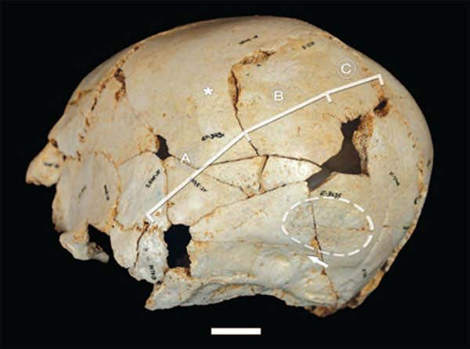
500,000 year old skull of child with craniosynostosis found in Spain in 2001
In 2001 a prehistoric skeleton of a child was found in Spain. After years of careful work, in 2009 the team announced that this child had a condition which changes the way the skull develops and could have caused learning disabilities.
The condition would have resulted in the child looking different. If the child had learning disabilities they would have needed support from their community to survive.
The boy or girl had been cared for and looked after for a long time – perhaps as much as twelve years.
We cannot be completely sure this little boy or girl had a learning disability and perhaps these early societies did not always care for those who needed extra help.
But we also know there are examples of times they did. There is skeletal evidence from other prehistoric sites showing people with physical disabilities were sometimes supported – perhaps this is evidence people who found learning difficult were – at least sometimes – valued, included cared for and loved.

Did ancient societies exclude people with learning disabilities?
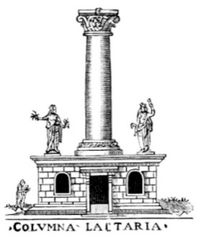
Diagram of the Comuna Lactaria in Ancient Rome. A place where unwanted children were known to be abandoned.
Ancient Greece and Rome
It is difficult to learn about the lives of people who could not read or write. In Ancient Greece and Rome although some people could read and write not much was written about those with learning disabilities.
Modern treatments for many medical conditions were not available in the Ancient World, which means the life expectancy of those with conditions such as Downs Syndrome – which often causes problems with health as well as learning disability - was probably much shorter than it is today.
The exclusion of people with learning disabilities.
There is enough evidence for us to be learn life was very difficult for some people with learning disabilities, especially if these were obvious. Many people in Ancient Greece and Rome thought people with disabilities were cursed by gods.
In Ancient Greece parents of babies born with obvious disabilities sometimes left them outside to die.
In Ancient Rome children with learning disabilities may also have had a terrible time. There are reports of parents drowning them in the River Tiber that runs through the city. As in Ancient Greece children with disabilities were sometimes left outside on their own. This could involve leaving children in clay jars by the side of roads or at temples.
Were children with disabilities always killed?
We cannot be sure it was common to kill children. We know some people we would consider disabled today worked in different types of job.
Just because there were laws allowing the murder of children does not mean it always happened. Even when this did happen we still can’t be sure how people felt about it.
Perhaps leaving babies and children in places like temples where they knew they might be found rathe suggests the parents of these children hoped they would not die and would be adopted.
Finally, we know some children with learning disabilities were cared for by families who could afford to do so.
The end of killing children
The gradual spread of Christianity through the Roman Empire helped change attitudes towards all types of disability. In the Bible Jesus cares for those with disabilities and early Christian teachers such as St Paul taught people should ‘comfort the feeble-minded.’
Killing babies when they are born was eventually made illegal for any reason in Rome.

How fully were people with learning disabilities included in medieval and early modern society?
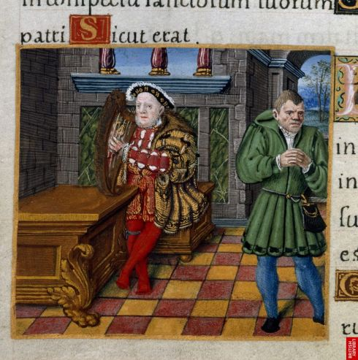
An image of Will Somer, an innocent fool in Henry VIII’s court from Henry’s personal psalter.
The Bible and the Christian Church
The medieval and early modern period was after the Ancient period.
In England the Christian Church was very powerful. People made decisions based on what it said in the Bible.
The Bible encouraged people to care for people who needed help. ‘Natural’ or ‘innocent’ fools, which is how people considered to have what might be described today as learning disabilities were supposed to be looked after by the king or queen. They were supposed to make sure they were supported until their death.

Natural and Innocent Fools.
Those described as being ‘natural fools’ probably did not include many people who would be regarded as having learning disabilities today. This is because – as in Ancient Greece - in a society in which few people could or needed to read and write there were more jobs in industries such as farming in which those who had trouble learning as fast as others could do and fit in.
We know less about poorer people with learning disabilities than we do richer people but we do know a bit. In 1383 a poor woman named Emma de Beston appeared before a crown court, who were trying to work out whether she could live on her own. Emma was asked questions to test her understanding of the world – these included the names of her children and whether one amount of money was worth more than another. The court listened to her answers and decided she was not able to live on her own. She would probably have been placed in the care of her community to help where she could and be helped to do things she couldn’t do on her own.
Life in medieval communities.
Whether rich or poor people with learning disabilities were included in the community. Being brave and loyal were seen to be important so there were ways in which people with learning disabilities could be valued.
Those with learning disabilities may have been thought odd or funny but would still have been viewed as being part of the communities in which they lived with useful things to offer. There was no suggestion those with learning disabilities should be separated or put in prison unless they were dangerous, and this only happened if the person had no friends or family who could look after them. Emma was asked the names of her children, which meant she had some and these were known to those questioning her – evidence she was included in society and contributed to it.
Why did rich families adopt natural and innocent fools?
Some rich noble families adopted people people born with learning disabilities.
‘Innocent fools’ would have been provided with food, clothing and shelter in exchange for providing entertainment for the family. Some were treated kindly but others would have been subjected to cruelty. If their Lord decided they no longer wanted them they could be cast out to beg what they could to survive. This did not always happen – often the fools of monarchs were given money and allowed to retire comfortably.
There are suggestions some royal Fools may have had real influence on their monarchs. Will Somer, who was an innocent fool in Henry VIII’s court may have played in a role in getting property back for Eston Neston after the King took it away and threw him in gaol.
There are moving accounts of the relatives of royal ‘innocent fools’ visiting them at court for many years where they were sometimes given presents by their kings and queens. This shows even when not living in the home communities, people with learning disabilities remained loved and cared for by their families.

What do Fanny and Thomas’ stories reveal about how far people with learning disabilities were included in 18th century society?
Fanny’s story
In 1764 a baby girl was born to a rich family. They named her Fanny. It soon became clear she had learning disabilities. Once, she asked her friends to “do it again” after she heard thunder because she thought they were controlling the weather.
Even as a young adult she needed help dressing and protection from dangers like the garden pond.

In 1786 she was kidnapped by an army lieutenant called Henry Bowerman, who tricked her into going to a nearby village by telling her there would be strawberries and cream. She was taken to France. Bowerman got an English priest drunk and he did the service.
When Fanny’s mother found out where her daughter was, she sent people to find Fanny. They found her and took her home to her mother.
The marriage was cancelled. Fanny was returned to her mother who now had legal guardianship of her.
This story shows that Fanny was loved and protected by her family.
Thomas’ Story

In 1780 a poor young man with learning disabilities who worked in a London meat market appeared in court accused of taking part in a riot.
He had been seen drunk helping destroy a house. Thomas could be hanged. His life was at stake.
At Thomas’ trial six people defended him, which included his workmates, his boss, his sister and his mother.
Everyone claimed he had been with them at the time of the riot. He couldn’t possibly have been with all the people who said he was with them at the same time!
The judge knew this and warned the witnesses they could themselves get into trouble for lying. He told them to be careful. They did not change their stories with one saying “I am very careful, and very sure he was employed in the yard until dinner-time.”
It seems pretty clear Thomas had taken part in the riot but the jury chose to go along with the witnesses stories probably because they thought the best place for him was in his community with his family and friends.
Thomas’ life was not perfect. We know he was teased and probably often treated badly, but when his life was at stake the people who knew him were willing to risk their own freedom to stop him being punished for committing a crime they knew he might not have really understood.
He was one of their own.
The judge and jurors were also happy to go along with the stories of Thomas’ friends, showing they thought the best place for him was in his community with his friends and family.

Why did 19th and 20th century societies lock away people with learning disabilities?
In the 19th century attitudes towards people with learning disabilities changed. More and more people began to think people with learning disabilities should be separated from the rest of the population.
A diagram wrongly interpreting Darwin’s work to mean human evolution is linear and progressive.
One reason for this was the development of new types of science influenced by Charles Darwin’s work on natural selection and evolution.
Although Darwin did not include humans in his theories some people interpreted them to mean there was a ladder of humans with some better than others.
Unimprovable?
Some people began to say people with learning disabilities were a waste of resources because they could never improve.
More and more people began to feel people with learning disabilities were a problem and should be separated from everyone else.
From the late 19th century just having a learning disability was seen as a good reason to shut people away.
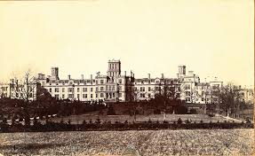
Earlswood asylum – a place in which people with learning disabilities were incarcerated in the 1800s.
With learning disability being increasingly seen as a medical problem hospitals and asylums were set up to house them in.
Doctors and other medical professionals decided who should go into these and supervised them. From 1913 colonies began to be constructed. Here people with learning disabilities were supposed to be supported in doing simple work while under supervision. Men and women were kept apart because of the fear they might have children. The people in them were closely controlled and allowed very little freedom
Many people grew up and died without ever seeing the outside world.

Why did some societies in the 20th century try to get rid of people with learning disabilities?
Eugenics
The arrangement of human reproduction to increase characteristics believed to be ‘good’, and to reduce or eliminate characteristics believed to be ‘bad’ is known as eugenics.
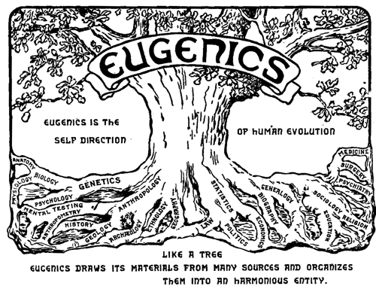
Logo from the Second International Conference of 1921, depicting eugenics as a tree which unites a variety of different fields
In the 1900s more and more people joined eugenics societies. The aim of these was to try and find ways humanity could be ‘improved’ by reducing the number of children born to less intelligent people.
Those with learning disabilities were considered particularly unsuitable parents because it was felt they would pass disabilities to their children.
Assumptions were made about the quality of life of those with learning disabilities. It was often said less intelligent people did not have the capacity for happiness or even human feelings.
Eugenics to murder
Eugenic ideas became common. In Britain this resulted in many sterilisations in which healthy people had operations that stopped them being able to have children.
The most upsetting example of eugenics occurred in Nazi Germany.
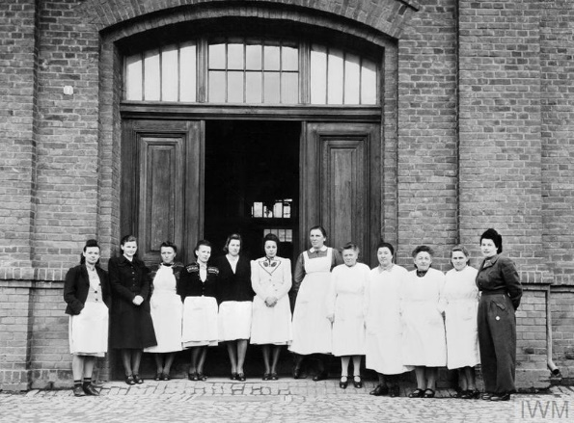
Nurses outside the Hartheim execution centre.
In 1939 the Nazi state began to kill children with learning disabilities, described by the law as being ‘garbage’.
Six places were fitted with gas chambers and by 1941 more than 40,000 people with learning disabilities had been killed.
The Nazis did their best to keep this secret and lied to the relatives of people they had murdered.
The Nazis were forced to end the centralised gassing programme after the relatives of murdered people found out and protested.

The end of open eugenics
The horrors of Nazi Germany disgusted people. People found the involvement of medical professionals particularly upsetting. British eugenic societies lost most of their members.
Ideas about learning disability were also changing. During the war people with learning disabilities who might not have been previously seen as fit to play a role in society had made obvious contributions.
Britain after the war was developing a different attitude towards people with learning disabilities.
But things did not change quickly.

Back in the community? – how included are people with learning disabilities now?
Life in hospital
Many people with learning disabilities continued to live in colonies, asylums and hospitals.
Those who worked in these institutions did not have option of returning the people to their communities and often did not understand how best to approach people who were different but not ill.
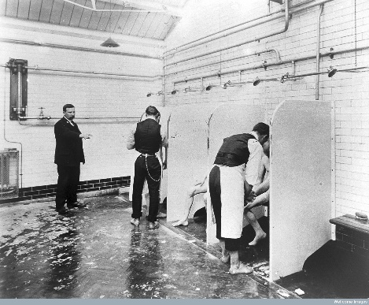
Bathing scene from a hospital used to house people with learning disabilities.
They were often horrible places. The people in them had little freedom.
“Taps were took off ‘cos they were like taps you had to screw on and when you’d had your bath they took ‘em away. Or else some people would kill themselves, drown themselves.”
People who would not comply with the rules were badly treated. The right to visit family or have visitors could be taken away for ‘bad behaviour’. Some were stripped naked to humiliate them or locked away in dark rooms. Breaking rules around interacting with the opposite sex were very harshly punished.
The birth of a baby with learning disabilities was viewed as an awful event with parents advised to send them away and have another. Parents who refused to do this were told they did not have the right to a free education for their child.
Return to inclusion
Some parents would not accept this and fought for recognition of their children as humans with the same rights as others. This was a hard thing to do. These parents set up support groups, schools, youth clubs and community hubs. Gradually, with the support of some influential celebrities, attitudes did begin to change.
From the 1950s laws changed to make it easier for people with learning disabilities to live in communities. Words that had become common insults, such as ‘idiot’ and ‘imbecile’ were discouraged.
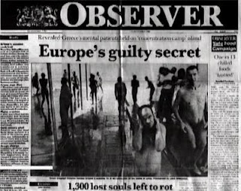
Front page of 1960s Observer newspaper reporting on a hospital in Greece..
Newspaper reporters found many cases in which people had been stolen from, threatened, verbally abused and beaten. In 1981 a team of film makers were invited to two hospitals and filmed a young person tied to a pillar, one locked in a room and forgotten about and others left without water or shade in a locked outdoor pen on a hot day.
Reports said people with learning disabilities had the right to live normal lives in normal communities and – like everyone else – should only live in a hospital if they had a medical condition that needed treatment they could not get in their own homes.
The return to life in the community has improved the lives of many people. Many people with learning disabilities now live in their own homes, have fulfilling lives and make their own decisions.
An athlete with Downs Syndrome competing at the Special Olympics.
How included are people with learning disabilities today?
This does not mean everything is fine.
People with learning disabilities have a shockingly lower life expectancy than those without. Far too few work in paid employment and many experience prejudice every day.
There are still many examples of people with learning disabilities being taken advantage of through crimes such as abuse and theft.
During the Covid 19 pandemic of 2020-21 the death rate of people with learning disabilities was up to six times that of those without. Conditions such as Downs Syndrome associated with learning disabilities are considered acceptable reasons to end pregnancies.
There is a long way go and this is not a journey with an inevitable happy ending.
There is always the possibility attitudes might become even more exclusive again.
Human rights apply to everyone. Everyone is human.
We are in this together.
If we fail to include everyone then all of us fail.
To both my children, Bessie and Rose. Different. Perfectly human.

https://www.newscientist.com/article/dn16873-early-humans-may-have-cared-for-disabled-young/
https://www.nytimes.com/2012/12/18/science/ancient-bones-that-tell-a-story-of-compassion.html
https://mn.gov/mnddc/parallels/one/3.html
Simon Jarrett. Those They Called Idiots. The idea of the disabled mind from 1700 to the present day. Reaktion Books. 2020. P38
https://www.youtube.com/watch?v=C5H0I_9FFpE
Simon Jarrett. Those They Called Idiots. The idea of the disabled mind from 1700 to the present day. Reaktion Books. 2020. P46
https://www.oldbaileyonline.org/browse.jsp?id=t17800628-113-defend1484&div=t17800628-113#highlight
Maggie Potts and Rebecca Fido, A Fit Person to be Removed: Personal Accounts of Life a Mental Deficiency Institution. Plymouth, 1991. P45
Simon Jarrett. Those They Called Idiots. The idea of the disabled mind from 1700 to the present day. Reaktion Books. 2020. P280
See Saba Salman (ed) Made Possible – Stories of Success by people with learning disabilities in their own words. Unbound. 2020.

